**Basic Text Formatting, Presentational Elements, Phrase Elements**

* HTML provides us with the ability for formatting text just like we do in MS word or any text editing software.
* HTML defines special elements for defining text with a special meaning.
* HTML uses elements like <b> and <i> for formatting output, like bold or italic text.

The basic text formatting elements are:

* <h1>, <h2>, <h3>, <h4>, <h5>, <h6>
* <p>, <br>, <pre>

**Note:** The elementsdisplayed varies from browser to browser. For example, the typefaces (“fonts” in personal computer terminology), the font sizes and the spaces around these elements.

**White Space and Flow:**

If you put several consecutive spaces between two words, the spaces would appear between two words, the spaces would appear between words onscreen, but this is not the case; by default, only one space will be displayed. This is known as **whitespace collapsing**. Similarly, if you start a new line your source document, you have consecutive empty lines, these will be ignored and simply treat as one space as will tab characters.

Example:

<p> This paragraph show how multiple spaces between words are treated as a single space.

It also demonstrates how the browser will treat multiple carriage returns (new lines) as a single space, too. </p>

Whitespace can be particularly helpful because it allows you to add extra space into your HTML. That will not show up when viewed in a browser. These spaces can be used to indent your code which makes it easier to read.

If you want to preserve the spaces in a document, you need to either use:

1. <pre> element:

It defines preformatted text. Text in <pre> element is displayed in a fixed-width font (usually called courier), and it preserve both spaces and line breaks.

Example:

<pre>

This is a

pre tag example.

</pre>

1. &nbsp; (entity reference) / Non-breaking space:

It is a space that will not break into a new line.

Example:

<p> this is an &nbsp; &nbsp; example. </p>

Advantage: Easy to remember

Disadvantage: All browser may not support all entity names.

**Creating Headings Using <hn> Elements:**

* HTML offers six level of headings, which use the elements <h1>, <h2>, <h3>, <h4>, <h5> and <h6>. Browsers display the <h1> element as the largest of six and <h6> as the smallest.

Source Code: Output:

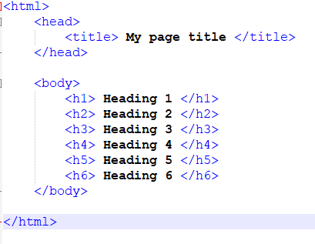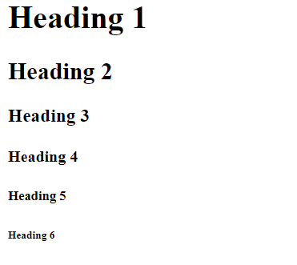

**Creating Paragraphs using the <p> Element:**

* The <p> element offers another way to structure your text. Each paragraph of text should go in between an opening <p> and closing </p> tag.

Source Code:

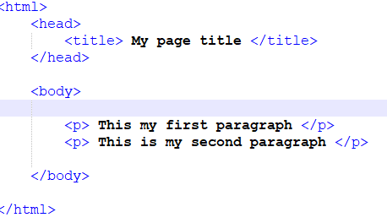

Output:

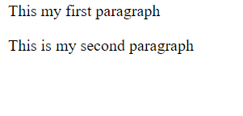

**Creating Line Breaks Using the <br /> Element:**

* Whenever you use the <br /> element, anything following it starts on the next line. The <br /> element is an example of an empty element; you don’t need opening and closing tags, because there is nothing to go between them.

Source Code:

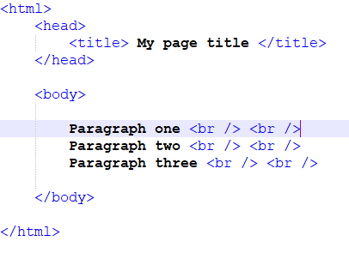

Output:

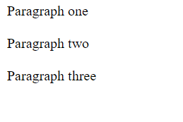

**Creating Preformatted Text Using the <pre> Element:**

* Sometime you want your text to follow the exact format of how it is written in the HTML document – you don’t want the text to wrap onto a new line when it reaches the edge of the browser; you don’t want it to ignore multiple spaces; and you want the line breaks where you put them.

Source Code:

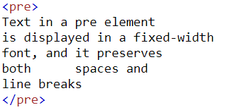

Output:

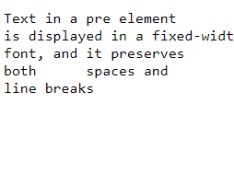

**Presentational Elements:**

There are a handful of (X)HTML elements that are explicitly presentation oriented. Sometimes called “physical” styles, they provide instructions for the size, weight, or style of the font used to display the element.

1. Bold Element(<b>):

Defines bold text

Syntax:

<b> This text is bold </b>

1. Big Element(<big>):

Defines big text

Syntax:

<big> This text is bigger </big>

1. Underline Element(<u>):

Defines underlined text

Syntax:

<p> I love <u>football</u>. <p>

1. Italic Element(<i>)

Defines italic text

Syntax:

<i> This text is italic. </i>

1. Small Element(<small>):

Defines small text

Syntax:

<small> This text is small. </small>

1. Strikethrough Element(<s> or <strike>):

Content is displayed with strikethrough.

Syntax:

<p>This is a example of <s>strikethrough</s>. </p>

1. Subscript (<sub>):

Defines subscripted text

Syntax:

<p>This text contains <sub>subscript</sub> text. </p>

1. Superscript(<sup>):

Defines superscripted text

Syntax:

<p>This text contains <sup>superscript</sup> text. </p>

1. Teletype Element(<tt>):

The text is written in monospaced font(machine like).

Syntax:

<p> <tt> This is teletype text<tt>.<p>

1. Deleted Text Element(<del>):

Defines deleted text.

Syntax:

<p>Following text is deleted using <del> HTML del tag </del>.<p>

1. Horizontal Line Element (<hr />):

It is an empty element like <br /> element. It is frequently used to separate distinct sections of a page where a new heading is not appropriate.

Syntax:

<h1>HTML</h1>

<p>HTML is a language for describing web pages. </p>

<hr />

<h1>CSS</h1>

<p>CSS defines how to display HTML elements. </p>

**Phrase Elements:**

The HTML phrase tags are special purpose tags, which defines the structural meaning of a block of text or semantics of text. Following is the list of phrase tags, some of which we have already discussed in HTML formatting.

1. Text Abbreviation Element:

This tag is used to abbreviate a text. To abbreviate a text, write text between <abbr> and </abbr> tag.

Example:

<p>An <abbr title = "Hypertext Markup language">HTML </abbr>language is used to create web pages. </p>

Source Code:

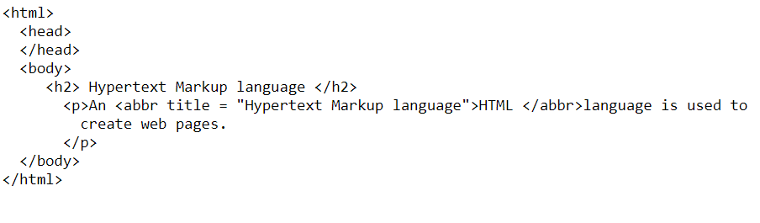

Output:

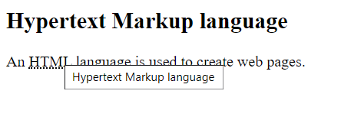

1. Marked Element:

The content written between <mark> and </mark> tag will show as yellow mark on browser. This tag is used to highlight a particular text.

Example:

<p>This tag will <mark>highlight</mark> the text.</p>

Source Code:

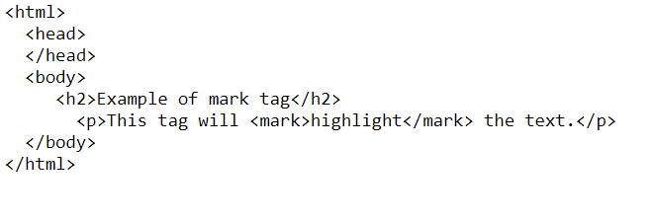

Output:

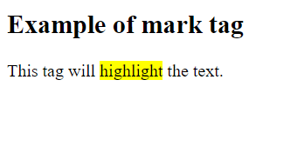

1. Strong Element:

This tag is used to display the important text of the content. The text written between <strong> and </strong> will be displayed as important text.

Example:

<p>In HTML it is recommended to use <strong>lowercase</strong>, while writing a code. </p>

Source Code:

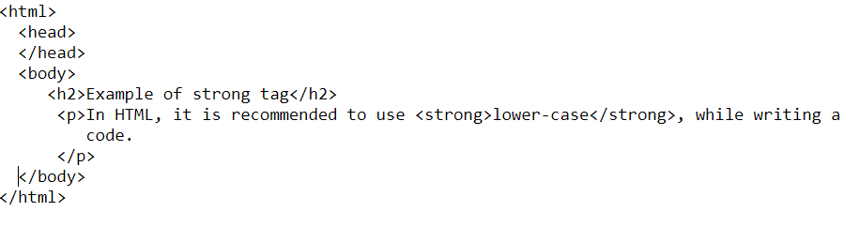

Output:

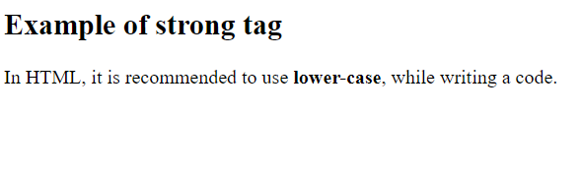

1. Emphasized Element:

This tag is used to emphasize the text, and displayed the text in italic form. The text written between <em> and </em> tag will italicize the text.

Example:

<p>HTML is an <em>easy </em>to learn language.</p>

Source Code:

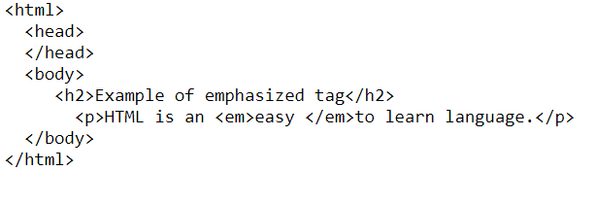

Output:

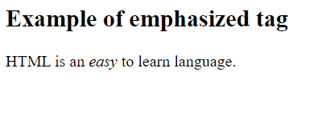

1. Definition Element:

When you use the <dfn> and </dfn> tags, it allows to specify the keyword of the content. Following is the example to show how to definition element.

Example:

<p><dfn>HTML </dfn> is a markup language. </p>

Source Code:

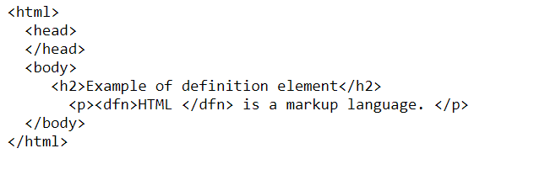

Output:

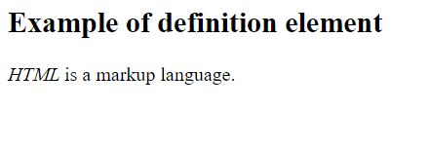

1. Quoting Element:

The HTML <blockquote> element shows that the enclosed content is quoted from another source. The Source URL can be given using the cite attribute, and text representation of source can display using **<cite> ..... </cite>element**.

Example:

<blockquote cite="https://www.keepinspiring.me/famous-quotes/"><p>”The first step toward success is taken when you refuse to be a captive of the environment in which you first find yourself.”</p></blockquote>

  <cite>-Mark Caine</cite>

Source Code:

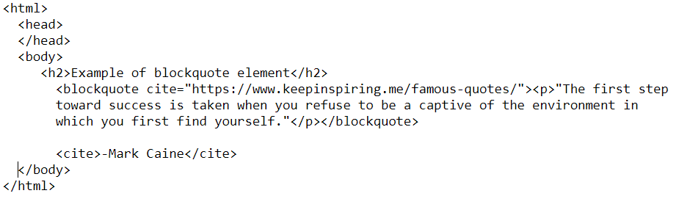

Output:

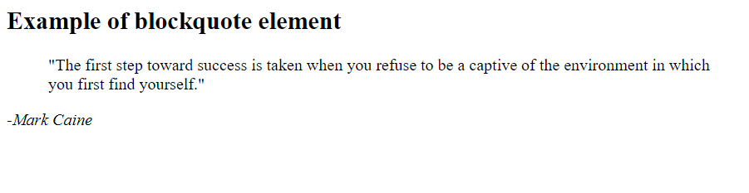

1. Short Quotation Element:

An HTML <q> ....... </q> element defines a short quotation. If you will put any content between <q> ....... </q>, then it will enclose the text in double quotes.

Example:

<p>Steve Jobs said: <q>If You Are Working On Something That You Really Care About, You Don’t Have To Be Pushed. The Vision Pulls You.</q></p>

Source Code:

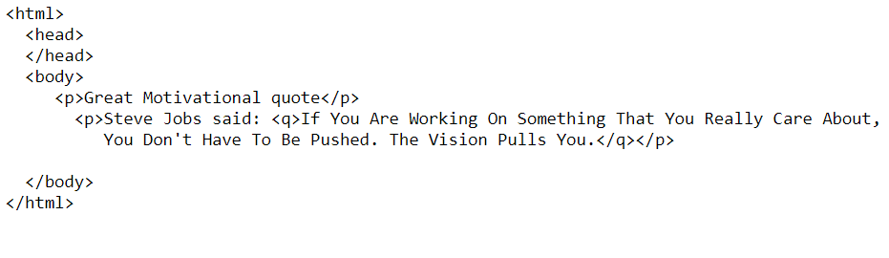

Output:

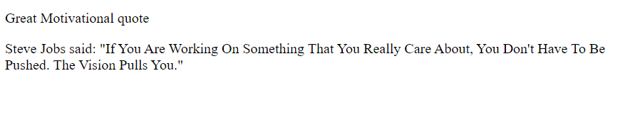

1. Code Element:

The HTML <code> </code> element is used to display the part of computer code. It will display the content in monospaced font.

Example:

<p>First Java program</p>

  <p><code>class Simple{ public static void main(String args[]){

        System.out.println("Hello Java"); }}</code>

      </p>

Source Code:

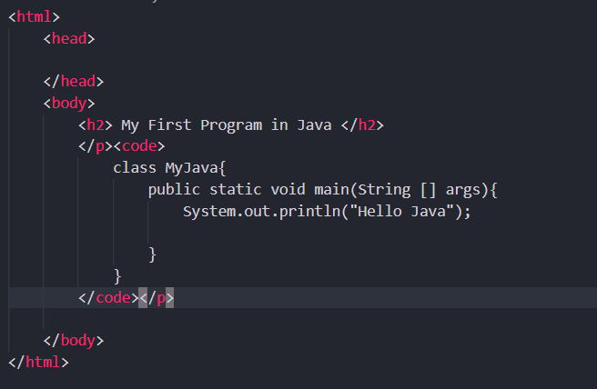

Output:

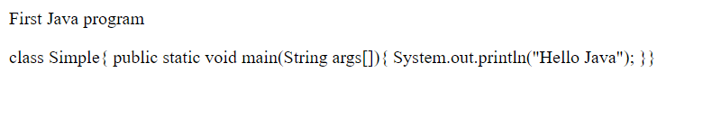

1. Keyboard Element:

In HTML the keyboard tag, <kbd>, indicates that a section of content is a user input from keyboard.

Example:

<p>Press <kbd>Ctrl</kbd> + <kbd>R</kbd> to reload page on chrome.</p>

Source Code:

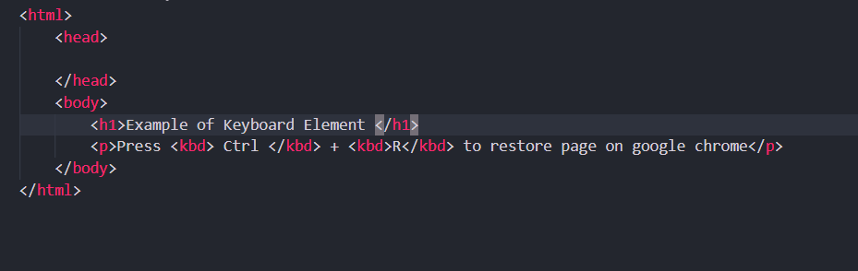

Output:

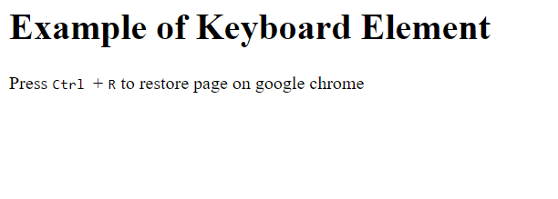

1. Address Element:

An HTML <address> tag defines the contact information about the author of the content. The content written between <address> and </address> tag, then it will be displayed in italic font.

Example:

<address> You can ask your queries by contacting us on <a href="">example123@google.com</a>

    <br> You can also visit at: <br>58 S. Garfield Street. Villa Rica, GA 30187.

   </address>

Source Code:

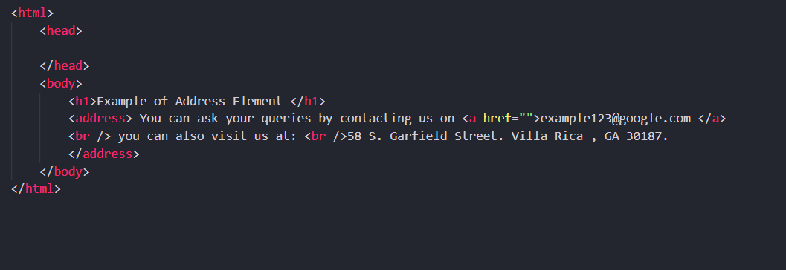

Output:

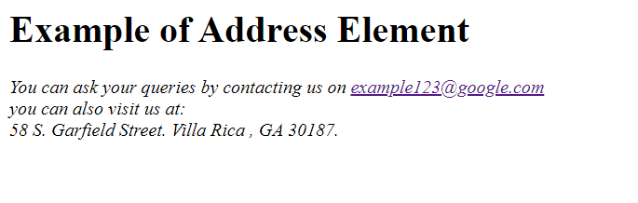

1. Var Element:

The < var > element is another of the elements added to help programmers. It is usually used in conjunction with the <pre> and <code> elements to indicate that the content of that element is a variable that can be supplied by a user.

Example:

<p> Sum of numbers: <var>y</var> = <var>a</var> + <var>b</var> </p>

Source Code:

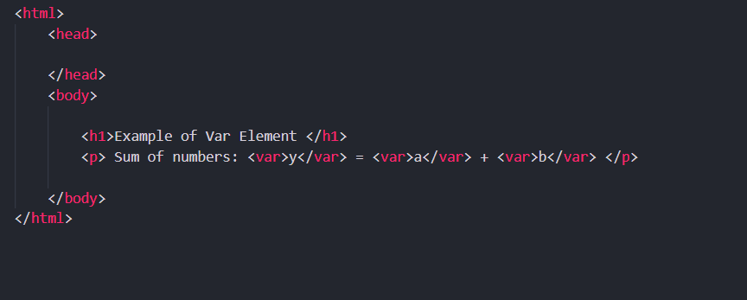

Output:

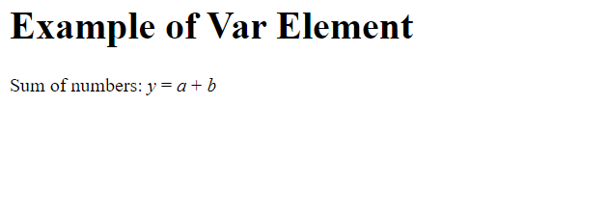

1. Samp Output Element (is from program output):

The < samp > element indicates sample output from a program, script, or the like. Again, it is mainly used when documenting programming concepts.

Example:

<p><samp>Error 5: Access is denied.</samp></p>

Source Code:

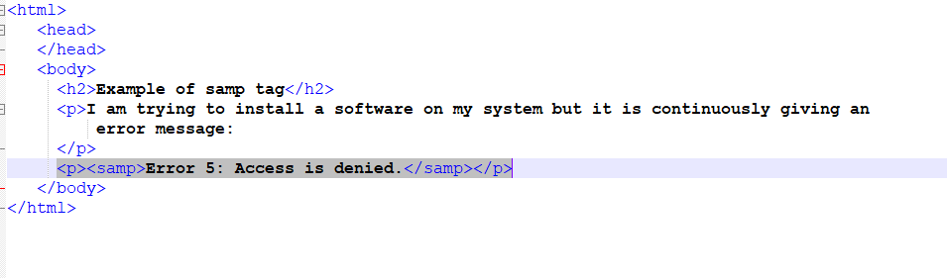

Output:

